Please review the entire document carefully before making any changes. I hope this will be the final round of revisions.
- PC version
- HOME
 Change it to this style



- Have 50 + Local Partners (change this )
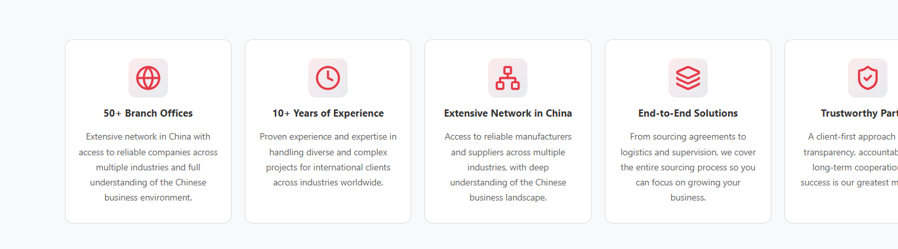

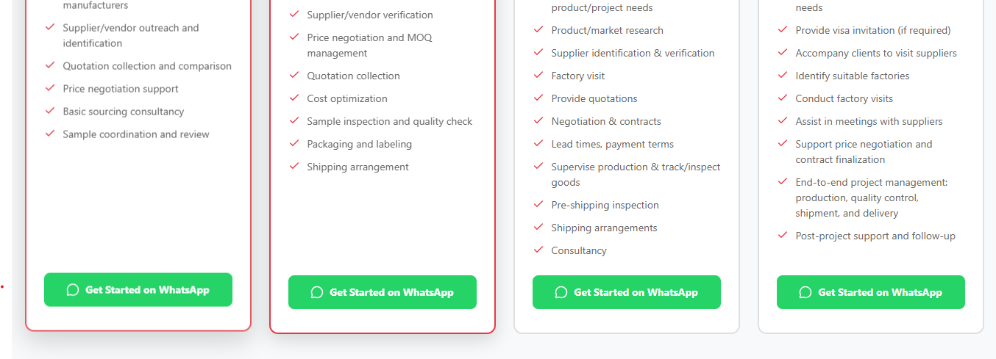
Change whatapp from pakistani Number to Chinese:
+8615618483542

- Product Page
To understand this part better check mobile version below
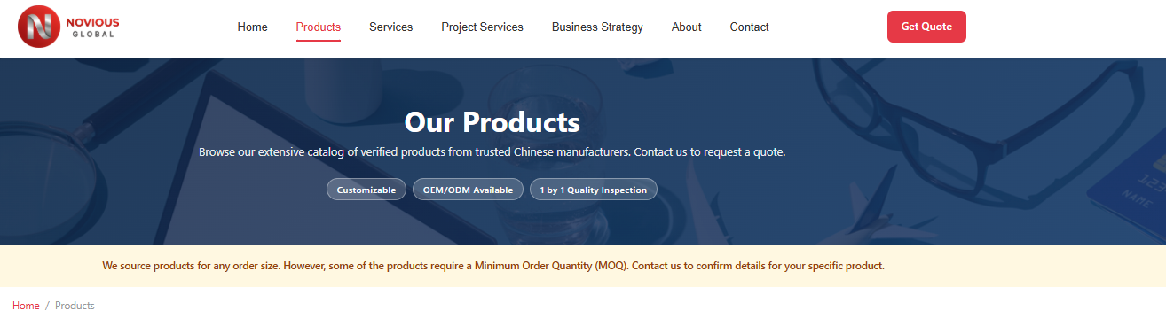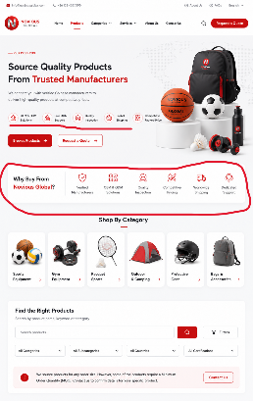

1 – Link the Chinese WhatsApp on products (and link with request quote)
2- Again CAN you Please pay attention to product names? Picture is different than the product name check below.

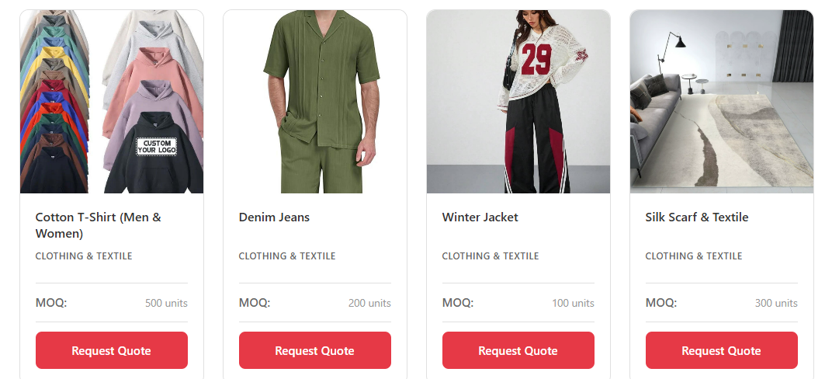
For example: This is clearly not winter but summer and this product must have a specific name you can check on AliExpress, e.g. (women XYZ baggy trouser- Summer outfit)

FOR Sports: Add More pictures: (give correct names, below are must to add, follow links check names, add pictures)
Seamless Gym Leggings Women Yoga Pants
Women Yoga Leggings Slim Yoga Pants
- https://www.aliexpress.com/item/1005007026201145.html?invitationCode=TUFmU0hHb0VTYVNxblFRM2hwVm1RSzJITWkxVU9uY3FRa09QaWpPcW53MmVQemFTZUJrNWVWT0s1MU1hdTAyWg&srcSns=sns_More&sourceType=570&spreadType=socialShare&social_params=22137099075&bizType=ProductDetail&spreadCode=TUFmU0hHb0VTYVNxblFRM2hwVm1RSzJITWkxVU9uY3FRa09QaWpPcW53MmVQemFTZUJrNWVWT0s1MU1hdTAyWg&aff_fcid=791798eef7fb46969a2af80c59ad0d99-1782867451992-04274-_mMlgrph&tt=MG&aff_fsk=_mMlgrph&aff_platform=default&sk=_mMlgrph&aff_trace_key=791798eef7fb46969a2af80c59ad0d99-1782867451992-04274-_mMlgrph&shareId=22137099075&businessType=ProductDetail&platform=AE&terminal_id=d821ae6b8dfe41ec97d43a0f552ecc9b&afSmartRedirect=y&gatewayAdapt=4itemAdapt

- https://www.aliexpress.com/item/1005010056026272.html?invitationCode=TUFmU0hHb0VTYVNteHlTWDhYUjRNNjJITWkxVU9uY3FRa09QaWpPcW53MmVQemFTZUJrNWVWT0s1MU1hdTAyWg&srcSns=sns_More&sourceType=570&spreadType=socialShare&social_params=22126308352&bizType=ProductDetail&spreadCode=TUFmU0hHb0VTYVNteHlTWDhYUjRNNjJITWkxVU9uY3FRa09QaWpPcW53MmVQemFTZUJrNWVWT0s1MU1hdTAyWg&aff_fcid=a8d3b22f31684d35b73e395ebbb60f06-1782867454260-03716-_mM9vGOR&tt=MG&aff_fsk=_mM9vGOR&aff_platform=default&sk=_mM9vGOR&aff_trace_key=a8d3b22f31684d35b73e395ebbb60f06-1782867454260-03716-_mM9vGOR&shareId=22126308352&businessType=ProductDetail&platform=AE&terminal_id=d821ae6b8dfe41ec97d43a0f552ecc9b&afSmartRedirect=y&gatewayAdapt=4itemAdapt

- https://www.aliexpress.com/item/1005008607780673.html?invitationCode=TUFmU0hHb0VTYVJHUHc0MEdLbTc3cTJITWkxVU9uY3FRa09QaWpPcW53MmVQemFTZUJrNWVWT0s1MU1hdTAyWg&srcSns=sns_More&sourceType=570&spreadType=socialShare&social_params=22121464022&bizType=ProductDetail&spreadCode=TUFmU0hHb0VTYVJHUHc0MEdLbTc3cTJITWkxVU9uY3FRa09QaWpPcW53MmVQemFTZUJrNWVWT0s1MU1hdTAyWg&aff_fcid=3a700cdbe319448cb140e2afeb7b0032-1782867491350-06110-_msCVw2R&tt=MG&aff_fsk=_msCVw2R&aff_platform=default&sk=_msCVw2R&aff_trace_key=3a700cdbe319448cb140e2afeb7b0032-1782867491350-06110-_msCVw2R&shareId=22121464022&businessType=ProductDetail&platform=AE&terminal_id=d821ae6b8dfe41ec97d43a0f552ecc9b&afSmartRedirect=y&gatewayAdapt=4itemAdapt

- https://www.aliexpress.com/item/1005007271288993.html?invitationCode=TUFmU0hHb0VTYVNpdzg5UmVMcUlYNjJITWkxVU9uY3FRa09QaWpPcW53MmVQemFTZUJrNWVWT0s1MU1hdTAyWg&srcSns=sns_More&sourceType=570&spreadType=socialShare&social_params=22121463210&bizType=ProductDetail&spreadCode=TUFmU0hHb0VTYVNpdzg5UmVMcUlYNjJITWkxVU9uY3FRa09QaWpPcW53MmVQemFTZUJrNWVWT0s1MU1hdTAyWg&aff_fcid=dc30c9e991e149d9929ed931c9dda3eb-1782867489930-07908-_mMCz5TV&tt=MG&aff_fsk=_mMCz5TV&aff_platform=default&sk=_mMCz5TV&aff_trace_key=dc30c9e991e149d9929ed931c9dda3eb-1782867489930-07908-_mMCz5TV&shareId=22121463210&businessType=ProductDetail&platform=AE&terminal_id=d821ae6b8dfe41ec97d43a0f552ecc9b&afSmartRedirect=y&gatewayAdapt=4itemAdapt

- https://www.aliexpress.com/item/1005008682768784.html?invitationCode=TUFmU0hHb0VTYVNyVFJ0clFSbnJKYTJITWkxVU9uY3FRa09QaWpPcW53MmVQemFTZUJrNWVWT0s1MU1hdTAyWg&srcSns=sns_More&sourceType=570&spreadType=socialShare&social_params=22121464146&bizType=ProductDetail&spreadCode=TUFmU0hHb0VTYVNyVFJ0clFSbnJKYTJITWkxVU9uY3FRa09QaWpPcW53MmVQemFTZUJrNWVWT0s1MU1hdTAyWg&aff_fcid=a28c0c5ec909493c8f030a0db790f658-1782867493254-04233-_msPIutl&tt=MG&aff_fsk=_msPIutl&aff_platform=default&sk=_msPIutl&aff_trace_key=a28c0c5ec909493c8f030a0db790f658-1782867493254-04233-_msPIutl&shareId=22121464146&businessType=ProductDetail&platform=AE&terminal_id=d821ae6b8dfe41ec97d43a0f552ecc9b&afSmartRedirect=y&gatewayAdapt=4itemAdapt
- https://www.aliexpress.com/item/1005006984848421.html?invitationCode=TUFmU0hHb0VTYVFGYlk0enhEdEV5NjJITWkxVU9uY3FRa09QaWpPcW53MmVQemFTZUJrNWVWT0s1MU1hdTAyWg&srcSns=sns_More&sourceType=570&spreadType=socialShare&social_params=22121461717&bizType=ProductDetail&spreadCode=TUFmU0hHb0VTYVFGYlk0enhEdEV5NjJITWkxVU9uY3FRa09QaWpPcW53MmVQemFTZUJrNWVWT0s1MU1hdTAyWg&aff_fcid=df2e529d920f4c76b429767a4eefd665-1782867459403-05081-_mrHTMlz&tt=MG&aff_fsk=_mrHTMlz&aff_platform=default&sk=_mrHTMlz&aff_trace_key=df2e529d920f4c76b429767a4eefd665-1782867459403-05081-_mrHTMlz&shareId=22121461717&businessType=ProductDetail&platform=AE&terminal_id=d821ae6b8dfe41ec97d43a0f552ecc9b&afSmartRedirect=y&gatewayAdapt=4itemAdapt
Please Add: Pet Supplies
- https://www.aliexpress.com/item/1005006415813548.html?invitationCode=TUFmU0hHb0VTYVFoc1ZlY0N6bStiSzJITWkxVU9uY3FRa09QaWpPcW53MmVQemFTZUJrNWVWT0s1MU1hdTAyWg&srcSns=sns_More&spreadType=socialShare&social_params=22121467297&bizType=ProductDetail&spreadCode=TUFmU0hHb0VTYVFoc1ZlY0N6bStiSzJITWkxVU9uY3FRa09QaWpPcW53MmVQemFTZUJrNWVWT0s1MU1hdTAyWg&aff_fcid=d61b04849e2d43e3b130787219944d10-1782867495228-01015-_mPOwMWX&tt=MG&aff_fsk=_mPOwMWX&aff_platform=default&sk=_mPOwMWX&aff_trace_key=d61b04849e2d43e3b130787219944d10-1782867495228-01015-_mPOwMWX&shareId=22121467297&businessType=ProductDetail&platform=AE&terminal_id=d821ae6b8dfe41ec97d43a0f552ecc9b&afSmartRedirect=y&gatewayAdapt=4itemAdapt

- https://www.aliexpress.com/item/1005007227308311.html?invitationCode=TUFmU0hHb0VTYVM5UXRxaVovOFhTYTJITWkxVU9uY3FRa09QaWpPcW53MmVQemFTZUJrNWVWT0s1MU1hdTAyWg&srcSns=sns_More&spreadType=socialShare&social_params=22121468168&bizType=ProductDetail&spreadCode=TUFmU0hHb0VTYVM5UXRxaVovOFhTYTJITWkxVU9uY3FRa09QaWpPcW53MmVQemFTZUJrNWVWT0s1MU1hdTAyWg&aff_fcid=93aaec49b6ea465490c0f6f39d55f660-1782867499539-08504-_mLlFU1H&tt=MG&aff_fsk=_mLlFU1H&aff_platform=default&sk=_mLlFU1H&aff_trace_key=93aaec49b6ea465490c0f6f39d55f660-1782867499539-08504-_mLlFU1H&shareId=22121468168&businessType=ProductDetail&platform=AE&terminal_id=d821ae6b8dfe41ec97d43a0f552ecc9b&afSmartRedirect=y&gatewayAdapt=4itemAdapt

- https://www.aliexpress.com/item/1005007222395799.html?invitationCode=TUFmU0hHb0VTYVFVU3NYTUhhQytPNjJITWkxVU9uY3FRa09QaWpPcW53MmVQemFTZUJrNWVWT0s1MU1hdTAyWg&srcSns=sns_More&spreadType=socialShare&social_params=22137107191&bizType=ProductDetail&spreadCode=TUFmU0hHb0VTYVFVU3NYTUhhQytPNjJITWkxVU9uY3FRa09QaWpPcW53MmVQemFTZUJrNWVWT0s1MU1hdTAyWg&aff_fcid=305aa4b102b14e4ba925ad4e179af25c-1782867528538-04333-_m007IOB&tt=MG&aff_fsk=_m007IOB&aff_platform=default&sk=_m007IOB&aff_trace_key=305aa4b102b14e4ba925ad4e179af25c-1782867528538-04333-_m007IOB&shareId=22137107191&businessType=ProductDetail&platform=AE&terminal_id=d821ae6b8dfe41ec97d43a0f552ecc9b&afSmartRedirect=y&gatewayAdapt=4itemAdapt

- https://www.aliexpress.com/item/1005006887446144.html?invitationCode=TUFmU0hHb0VTYVRCUFJBNlV5QUhqSzJITWkxVU9uY3FRa09QaWpPcW53MmVQemFTZUJrNWVWT0s1MU1hdTAyWg&srcSns=sns_More&spreadType=socialShare&social_params=22137103912&bizType=ProductDetail&spreadCode=TUFmU0hHb0VTYVRCUFJBNlV5QUhqSzJITWkxVU9uY3FRa09QaWpPcW53MmVQemFTZUJrNWVWT0s1MU1hdTAyWg&aff_fcid=667151e9435046f288bf3c63291ee17b-1782867497079-04281-_mORYbST&tt=MG&aff_fsk=_mORYbST&aff_platform=default&sk=_mORYbST&aff_trace_key=667151e9435046f288bf3c63291ee17b-1782867497079-04281-_mORYbST&shareId=22137103912&businessType=ProductDetail&platform=AE&terminal_id=d821ae6b8dfe41ec97d43a0f552ecc9b&afSmartRedirect=y&gatewayAdapt=4itemAdapt

- https://www.aliexpress.com/item/1005009911519731.html?invitationCode=TUFmU0hHb0VTYVFGRnJnT1ZTY1VCcTJITWkxVU9uY3FRa09QaWpPcW53MmVQemFTZUJrNWVWT0s1MU1hdTAyWg&srcSns=sns_More&spreadType=socialShare&social_params=22126316359&bizType=ProductDetail&spreadCode=TUFmU0hHb0VTYVFGRnJnT1ZTY1VCcTJITWkxVU9uY3FRa09QaWpPcW53MmVQemFTZUJrNWVWT0s1MU1hdTAyWg&aff_fcid=d36f51695b044e64a69abc0b8e53056b-1782867526119-08695-_m0WQeaB&tt=MG&aff_fsk=_m0WQeaB&aff_platform=default&sk=_m0WQeaB&aff_trace_key=d36f51695b044e64a69abc0b8e53056b-1782867526119-08695-_m0WQeaB&shareId=22126316359&businessType=ProductDetail&platform=AE&terminal_id=d821ae6b8dfe41ec97d43a0f552ecc9b&afSmartRedirect=y&gatewayAdapt=4itemAdapt

- https://www.aliexpress.com/item/1005009695150543.html?spm=a2g0o.tm1000056545.d245.d245.59026f3dYcwTpn&pvid=4a9b76ed-33d3-4a9c-8766-9fb689c22bd4&pdp_ext_f=%7B%22ship_from%22%3A%22CN%22%2C%22sku_id%22%3A%2212000049997369390%22%7D&scm=1007.57594.431530.0&scm-url=1007.57594.431530.0&scm_id=1007.57594.431530.0&pdp_npi=6%40dis%21USD%21US+%2418.26%21US+%248.58%21%21%21123.46%2158.03%21%400b830cc417828677029062499e30f3%2112000049997369390%21gdf%21US%217787283303%21X%211%210%21n_tag%3A-29910%3Bd%3A55a7acbe%3Bm03_new_user%3A-29895&mainPicRatio=1&aecmd=true&gatewayAdapt=4itemAdapt

- https://www.aliexpress.com/item/1005007162178169.html?invitationCode=TUFmU0hHb0VTYVNrR0lnbmZ3S1dENjJITWkxVU9uY3FRa09QaWpPcW53MmVQemFTZUJrNWVWT0s1MU1hdTAyWg&srcSns=sns_More&sourceType=570&spreadType=socialShare&social_params=22121472037&bizType=ProductDetail&spreadCode=TUFmU0hHb0VTYVNrR0lnbmZ3S1dENjJITWkxVU9uY3FRa09QaWpPcW53MmVQemFTZUJrNWVWT0s1MU1hdTAyWg&aff_fcid=3f14749fe9434a80a9d3f2e32a2b8716-1782867530602-00574-_mKGMmll&tt=MG&aff_fsk=_mKGMmll&aff_platform=default&sk=_mKGMmll&aff_trace_key=3f14749fe9434a80a9d3f2e32a2b8716-1782867530602-00574-\_mKGMmll&shareId=22121472037&businessType=ProductDetail&platform=AE&terminal_id=d821ae6b8dfe41ec97d43a0f552ecc9b&afSmartRedirect=y&gatewayAdapt=4itemAdapt

- https://www.aliexpress.com/item/1005006727644495.html?invitationCode=TUFmU0hHb0VTYVRvcThFbTlQSXRCSzJITWkxVU9uY3FRa09QaWpPcW53MmVQemFTZUJrNWVWT0s1MU1hdTAyWg&srcSns=sns_More&spreadType=socialShare&social_params=22133534117&bizType=ProductDetail&spreadCode=TUFmU0hHb0VTYVRvcThFbTlQSXRCSzJITWkxVU9uY3FRa09QaWpPcW53MmVQemFTZUJrNWVWT0s1MU1hdTAyWg&aff_fcid=17393593be3842c1b1f14f62b71efe75-1782867553159-01769-_mtRRtbd&tt=MG&aff_fsk=_mtRRtbd&aff_platform=default&sk=_mtRRtbd&aff_trace_key=17393593be3842c1b1f14f62b71efe75-1782867553159-01769-_mtRRtbd&shareId=22133534117&businessType=ProductDetail&platform=AE&terminal_id=d821ae6b8dfe41ec97d43a0f552ecc9b&afSmartRedirect=y&gatewayAdapt=4itemAdapt

- https://www.aliexpress.com/item/1005005994632134.html?invitationCode=TUFmU0hHb0VTYVFnMjlnTEJ5Vy9hSzJITWkxVU9uY3FRa09QaWpPcW53MmVQemFTZUJrNWVWT0s1MU1hdTAyWg&srcSns=sns_More&spreadType=socialShare&social_params=22133535692&bizType=ProductDetail&spreadCode=TUFmU0hHb0VTYVFnMjlnTEJ5Vy9hSzJITWkxVU9uY3FRa09QaWpPcW53MmVQemFTZUJrNWVWT0s1MU1hdTAyWg&aff_fcid=6036d20924f44e2085cb2362a3a4e138-1782867555576-00654-_mrl8ctz&tt=MG&aff_fsk=_mrl8ctz&aff_platform=default&sk=_mrl8ctz&aff_trace_key=6036d20924f44e2085cb2362a3a4e138-1782867555576-00654-_mrl8ctz&shareId=22133535692&businessType=ProductDetail&platform=AE&terminal_id=d821ae6b8dfe41ec97d43a0f552ecc9b&afSmartRedirect=y&gatewayAdapt=4itemAdapt

- https://www.aliexpress.com/item/1005008904709518.html?invitationCode=TUFmU0hHb0VTYVM3TDFrZWFGVkVzYTJITWkxVU9uY3FRa09QaWpPcW53MmVQemFTZUJrNWVWT0s1MU1hdTAyWg&srcSns=sns_More&spreadType=socialShare&social_params=22126317065&bizType=ProductDetail&spreadCode=TUFmU0hHb0VTYVM3TDFrZWFGVkVzYTJITWkxVU9uY3FRa09QaWpPcW53MmVQemFTZUJrNWVWT0s1MU1hdTAyWg&aff_fcid=f023303981364d008117daf34ca60e60-1782867526620-08850-_mqDvmh9&tt=MG&aff_fsk=_mqDvmh9&aff_platform=default&sk=_mqDvmh9&aff_trace_key=f023303981364d008117daf34ca60e60-1782867526620-08850-_mqDvmh9&shareId=22126317065&businessType=ProductDetail&platform=AE&terminal_id=d821ae6b8dfe41ec97d43a0f552ecc9b&afSmartRedirect=y&gatewayAdapt=4itemAdapt

Add in electronics:
https://www.aliexpress.com/item/1005005987111600.html?invitationCode=TUFmU0hHb0VTYVJUdjFIVW9pMHVSNjJITWkxVU9uY3FRa09QaWpPcW53MmVQemFTZUJrNWVWT0s1MU1hdTAyWg&srcSns=sns_More&spreadType=socialShare&social_params=22121476172&bizType=ProductDetail&spreadCode=TUFmU0hHb0VTYVJUdjFIVW9pMHVSNjJITWkxVU9uY3FRa09QaWpPcW53MmVQemFTZUJrNWVWT0s1MU1hdTAyWg&aff_fcid=733400d5b812451ba28d2df0114e13ef-1782867557769-03276-_mrplrqT&tt=MG&aff_fsk=_mrplrqT&aff_platform=default&sk=_mrplrqT&aff_trace_key=733400d5b812451ba28d2df0114e13ef-1782867557769-03276-_mrplrqT&shareId=22121476172&businessType=ProductDetail&platform=AE&terminal_id=d821ae6b8dfe41ec97d43a0f552ecc9b&afSmartRedirect=y&gatewayAdapt=4itemAdapt
https://www.aliexpress.com/item/1005011609711448.html?spm=a2g0o.productlist.seoads.3.4e125ccanA5IjK&p4p_pvid=2026063017595512149923462928460000546057_2
https://www.aliexpress.com/item/1005009282571408.html?invitationCode=TUFmU0hHb0VTYVJ6cVV3OGtVNEx6SzJITWkxVU9uY3FRa09QaWpPcW53MmVQemFTZUJrNWVWT0s1MU1hdTAyWg&srcSns=sns_More&spreadType=socialShare&social_params=22126319538&bizType=ProductDetail&spreadCode=TUFmU0hHb0VTYVJ6cVV3OGtVNEx6SzJITWkxVU9uY3FRa09QaWpPcW53MmVQemFTZUJrNWVWT0s1MU1hdTAyWg&aff_fcid=e344f580b233498a9b23085b4586f807-1782867559183-06336-_mKWavkn&tt=MG&aff_fsk=_mKWavkn&aff_platform=default&sk=_mKWavkn&aff_trace_key=e344f580b233498a9b23085b4586f807-1782867559183-06336-_mKWavkn&shareId=22126319538&businessType=ProductDetail&platform=AE&terminal_id=d821ae6b8dfe41ec97d43a0f552ecc9b&afSmartRedirect=y&gatewayAdapt=4itemAdapt
https://www.aliexpress.com/item/1005012057216098.html?spm=a2g0o.tm1000056545.d77.d77.59026f3dYcwTpn&pvid=d71875ef-7c94-4a66-9eb2-601b317a10ed&pdp_ext_f=%7B%22ship_from%22%3A%22CN%22%2C%22sku_id%22%3A%2212000057387841879%22%7D&scm=1007.57594.431530.0&scm-url=1007.57594.431530.0&scm_id=1007.57594.431530.0&pdp_npi=6%40dis%21USD%21US+%2419.61%21US+%248.04%21%21%21132.60%2154.37%21%400b830cc417828676811452309e30f3%2112000057387841879%21gdf%21US%217787283303%21X%211%210%21n_tag%3A-29910%3Bd%3A55a7acbe%3Bm03_new_user%3A-29895&mainPicRatio=1&aecmd=true&gatewayAdapt=4itemAdapt
https://www.aliexpress.com/item/1005005565214375.html?invitationCode=TUFmU0hHb0VTYVFHSGVKMTJyNVphSzJITWkxVU9uY3FRa09QaWpPcW53MmVQemFTZUJrNWVWT0s1MU1hdTAyWg&srcSns=sns_More&sourceType=570&spreadType=socialShare&social_params=22126309172&bizType=ProductDetail&spreadCode=TUFmU0hHb0VTYVFHSGVKMTJyNVphSzJITWkxVU9uY3FRa09QaWpPcW53MmVQemFTZUJrNWVWT0s1MU1hdTAyWg&aff_fcid=ae1ca1bbff57472ea9d693e3f4e1fb40-1782867486678-07482-_m0dEDFz&tt=MG&aff_fsk=_m0dEDFz&aff_platform=default&sk=_m0dEDFz&aff_trace_key=ae1ca1bbff57472ea9d693e3f4e1fb40-1782867486678-07482-_m0dEDFz&shareId=22126309172&businessType=ProductDetail&platform=AE&terminal_id=d821ae6b8dfe41ec97d43a0f552ecc9b&afSmartRedirect=y&gatewayAdapt=4itemAdapt
https://www.aliexpress.com/item/1005009913320127.html?spm=a2g0o.tm1000056545.d133.d133.59026f3dYcwTpn&pvid=0750cdfb-30a5-44ac-8f24-6df72ef59ac5&pdp_ext_f=%7B%22ship_from%22%3A%22CN%22%2C%22sku_id%22%3A%2212000050560278185%22%7D&scm=1007.57594.431530.0&scm-url=1007.57594.431530.0&scm_id=1007.57594.431530.0&pdp_npi=6%40dis%21USD%21US+%249.86%21US+%244.83%21%21%2166.64%2132.65%21%400b830cc417828676886292366e30f3%2112000050560278185%21gdf%21US%217787283303%21X%211%210%21n_tag%3A-29910%3Bd%3A55a7acbe%3Bm03_new_user%3A-29895&mainPicRatio=1&aecmd=true&gatewayAdapt=4itemAdapt
https://www.aliexpress.com/item/1005011938143442.html?spm=a2g0o.productlist.main.40.4e125ccanA5IjK&aem_p4p_detail=202606301759521056174535394700000520230&algo_pvid=1714a434-0feb-4440-872c-2ced3e1979c2&algo_exp_id=1714a434-0feb-4440-872c-2ced3e1979c2-39&pdp_ext_f=%7B%22order%22%3A%221670%22%2C%22eval%22%3A%221%22%2C%22fromPage%22%3A%22search%22%7D&pdp_npi=6%40dis%21USD%218.09%213.80%21%21%2154.67%2125.69%21%402132946217828675918365633e0fe6%2112000057076221667%21sea%21US%217787283303%21ABX%211%210%21n_tag%3A-29910%3Bd%3A55a7acbe%3Bm03_new_user%3A-29895&curPageLogUid=qKQMYQW0HEcX&utparam-url=scene%3Asearch%7Cquery_from%3A%7Cx_object_id%3A1005011938143442%7C_p_origin_prod%3A&search_p4p_id=202606301759521056174535394700000520230_10&gatewayAdapt=4itemAdapt

Add in Clothing: https://www.aliexpress.com/item/1005005993007395.html?invitationCode=TUFmU0hHb0VTYVFXd0pLRVo1U21PNjJITWkxVU9uY3FRa09QaWpPcW53MmVQemFTZUJrNWVWT0s1MU1hdTAyWg&srcSns=sns_More&sourceType=570&spreadType=socialShare&social_params=22133522065&bizType=ProductDetail&spreadCode=TUFmU0hHb0VTYVFXd0pLRVo1U21PNjJITWkxVU9uY3FRa09QaWpPcW53MmVQemFTZUJrNWVWT0s1MU1hdTAyWg&aff_fcid=0b874cf67c3746a594152f5899e5d5bb-1782867484714-01663-_mNBjM1V&tt=MG&aff_fsk=_mNBjM1V&aff_platform=default&sk=_mNBjM1V&aff_trace_key=0b874cf67c3746a594152f5899e5d5bb-1782867484714-01663-_mNBjM1V&shareId=22133522065&businessType=ProductDetail&platform=AE&terminal_id=d821ae6b8dfe41ec97d43a0f552ecc9b&afSmartRedirect=y&gatewayAdapt=4itemAdapt
Check links for better understanding:
Furniture: https://www.aliexpress.com/p/calp-plus/index.html?spm=a2g0o.home.tab.1.650c6278Q1N4vN&osf=category_navigate_newTab2&queryFrom=kingKong&categoryTab=furniture
Men Clothing: https://www.aliexpress.com/p/calp-plus/index.html?spm=a2g0o.home.tab.9.650c6278E9SQHS&osf=category_navigate_newTab2&queryFrom=kingKong&categoryTab=men%27s_clothing
Women bags: https://www.aliexpress.com/w/wholesale-woman-bags.html?spm=a2g0o.home.auto_suggest.2.650c6278E9SQHS

- Services
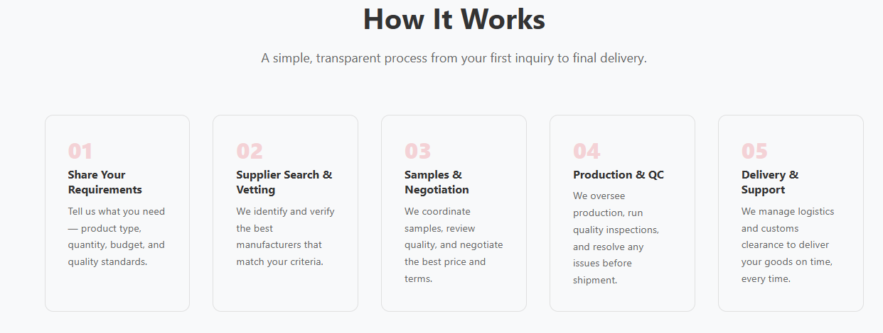
 Change it to this style

- Project service:
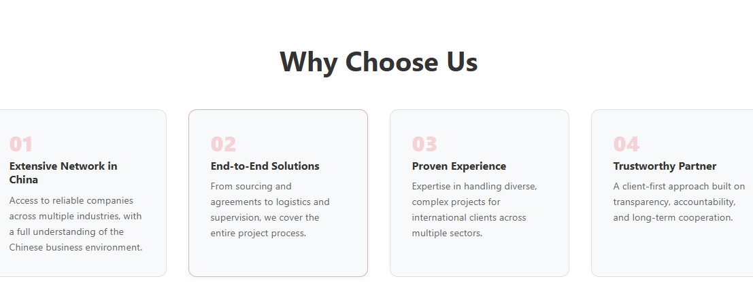
 Change it to this style

- Business Strategy (Instead, add original Logos)


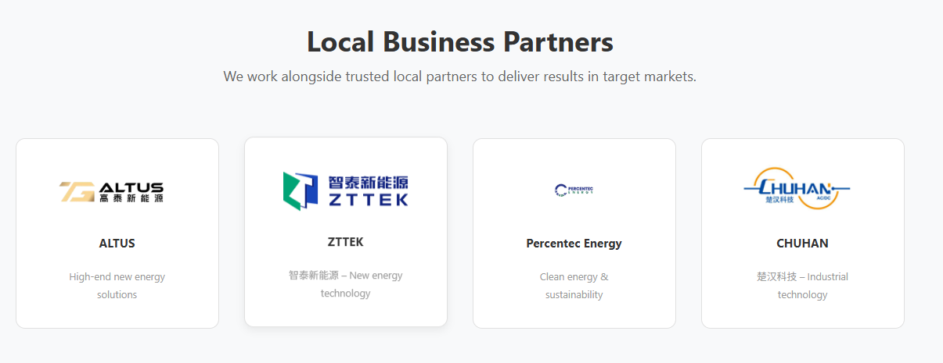

- About US
Please Add this picture her. upskale or improve the resulution




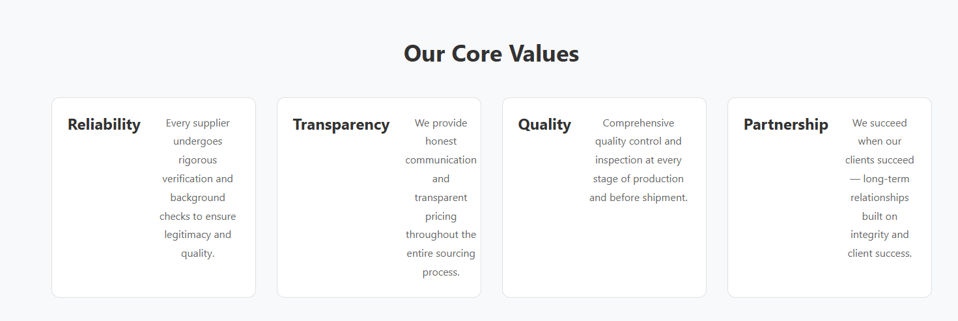
Fix text alignment and add some icons

Add this type of panel after “ Our core values:
- Me, 2- Abdul dul Rehman 3- Jack Wang (chinese) 4- Williomson white male
You have my picture, but for others, find any picture change them a bit using AI and add them accordingly (must look realistic).

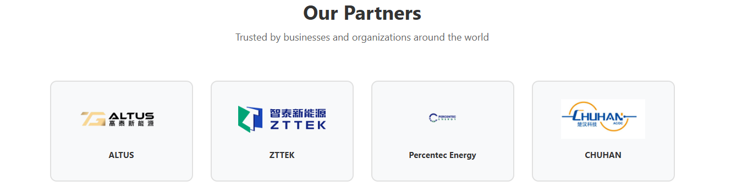

- In contact
Remove Pakistani WhatsApp number, BUT both Numbers (Chinese +Pakistani) should be added in contacts

Here you can add a grid of multiple real pictures

Change WhatsApp: +8615618483542 (Everywhere + social media logos in the end of every page)
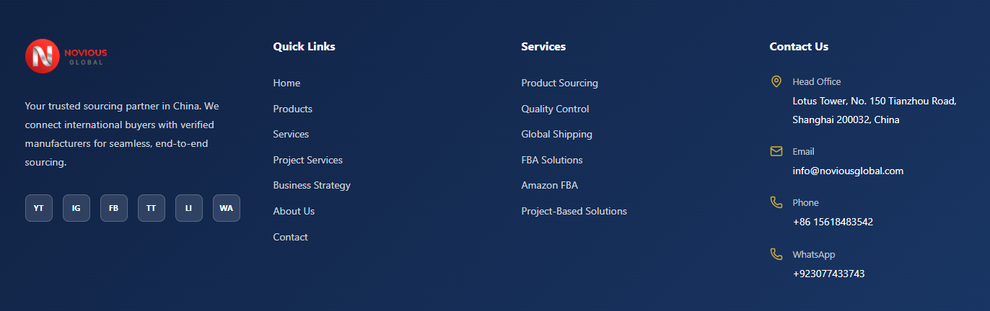
FINAL
Please add real images from the folder I shared with you. In particular, there are higher-quality and a variety of pictures in the initial files I sent you MUST CHECK, please review them carefully and use them appropriately where they best fit. We don’t need to add all pictures but we need few as testimonials. Prioritize placing them in (1) About Us, (2) Services, and (3) Home pages.

- Mobile Version
Home (this text should be below the headings, same as the others).
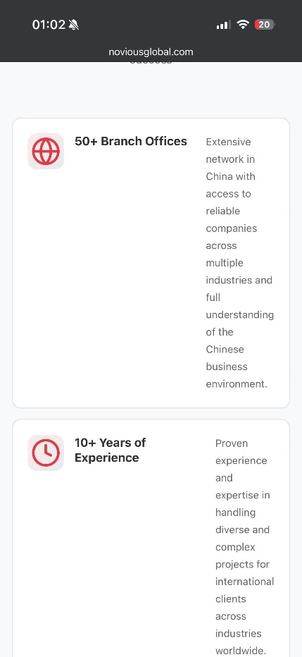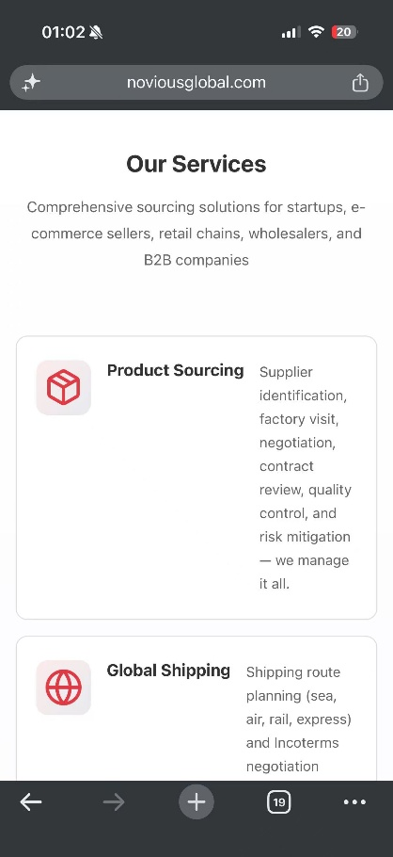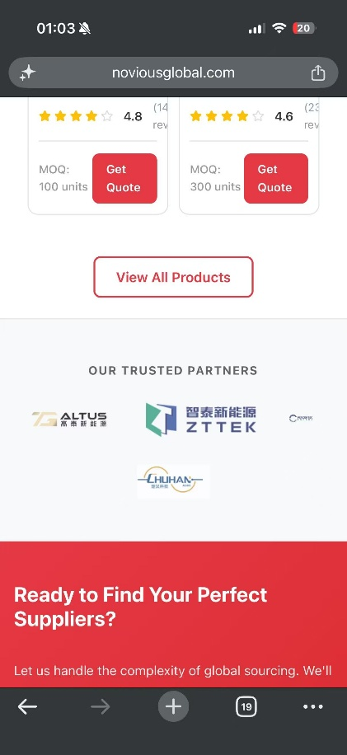
Percentec Logo is very smaller than others
1-home page, 2-about us page

Product Page
Image1#: I request you to open this page on your mobile and experience it as a user. For reference, if you click on any of these categories, users won’t be able to see the products instantly or any changes because, if they want to notice changes based on category selection, they have to scroll down, which is not good at all. Imagine you have just landed on the site and keep clicking on these categories but don’t see any changes unless you scroll down. So this needs to be fixed in the mobile version. I don’t know how, but I want to see the products appear right after clicking on the category, even without scrolling down. I hope you get my point.
Image#2Add catchy icons to improve asthetics
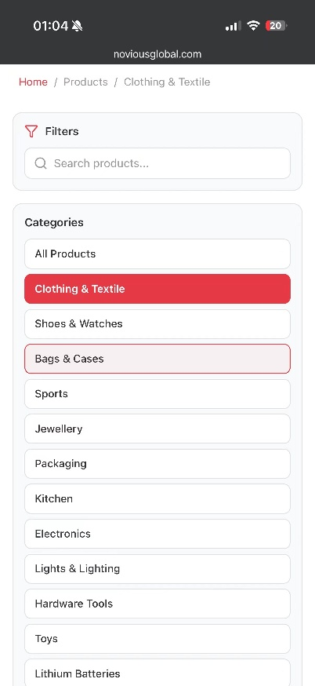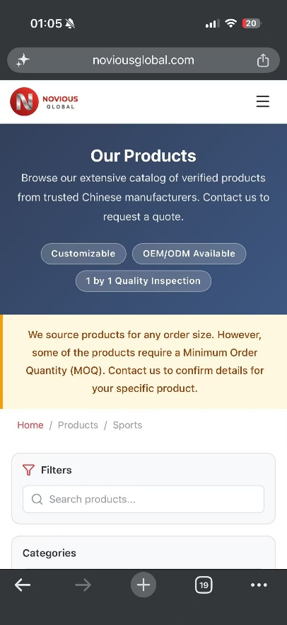
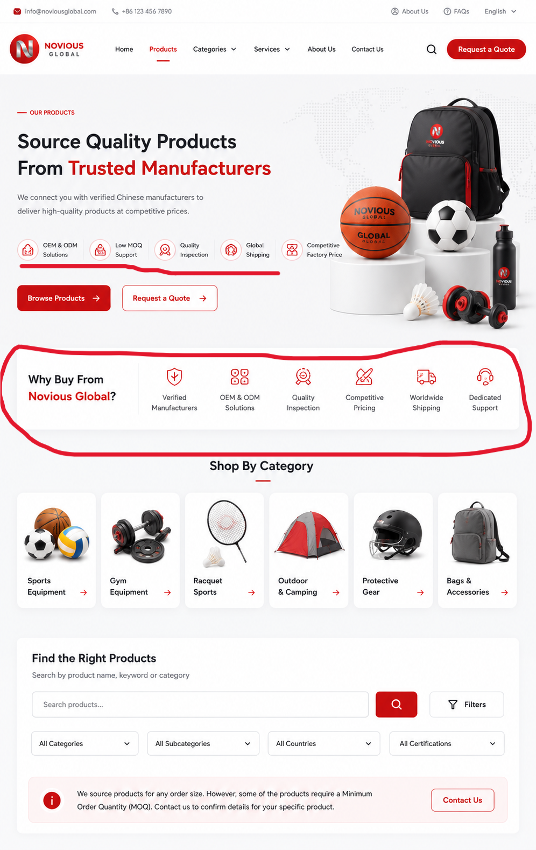

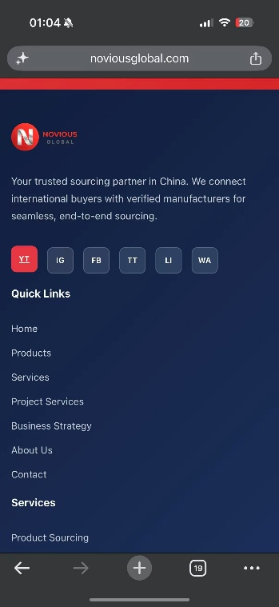
Add Original Social Media Logos & increase the size to keep in the one line. Change on ALL the PAGES

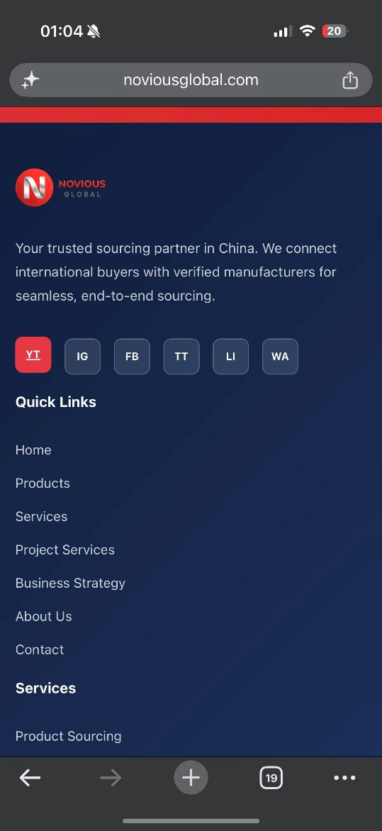
Add Original Social Media Logos & increase the size to keep in the one line. Change on ALL the PAGES

